**Pruebas de Caja Blanca - Camino básico**

**Grupo 4:**

**Ana Maria Riaño Caro**

**Anibal Yesith Oviedo Madera**

**Alexis Luque Orozco**

**Carlos Daniel Giraldo Naranjo**

**Karol Valentina Ávila Quintero**

**David Santiago Vargas Oyola**

**Instructor: Javier Leonardo Pineda Uribe**

**Graciela Arias Vargas**

**Análisis y Desarrollo de Sistemas de Información**

**Bogota D.C**

**15 de Agosto del 2022**

**SENA**

**Ingreso como usuario** **3**

**Registro de usuario** **4**

Grafos (Gráfico) 4

Grafos Caminos 5

Grafos tabla 5

**Matriz CRUD (Crear)** **6**

Grafos (Gráfico) 6

Grafos Caminos 6

Grafos tabla 6

**Matriz CRUD (Leer)** **7**

Grafos (Gráfico) 7

Grafos Caminos 7

Grafos tabla 7

**Matriz CRUD (Actualizar)** **8**

Grafos (Gráfico) 8

Grafos Caminos 8

Grafos tabla 8

**Matriz CRUD (Eliminar)** **9**

Grafos (Gráfico) 9

Grafos Caminos 9

Grafos tabla 9

# Registro de Usuario

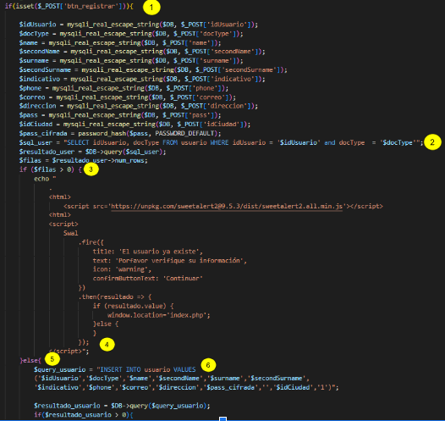

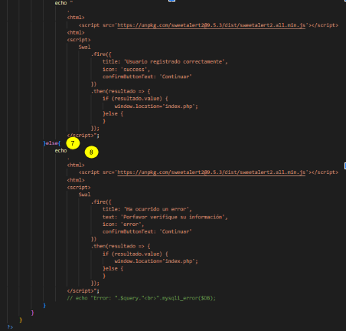

## Grafos (Gráfico)

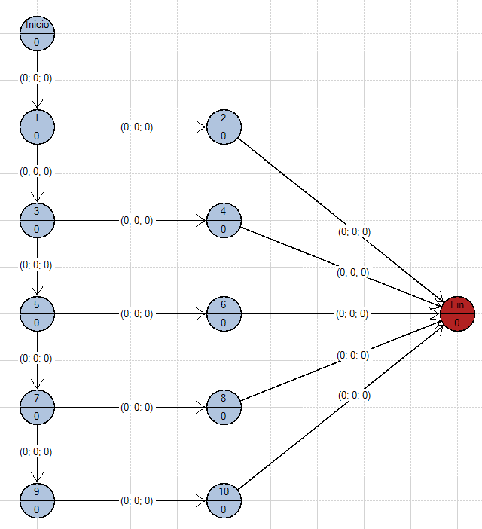

**V(G)= #ARISTA - #NODOS + 2 => V(G)= 15 - 10 + 2 = 7**

## Grafos Caminos

**Camino 1:** 1-2-3-fin

**Camino 2:** 1-4-5-6-fin

**Camino 3:** 1-4-7-8-9-fin

**Camino 4:** 1-4-7-10-11-12-fin

**Camino 5:** 1-4-7-10-13-14-15-fin

## 

## Grafos tabla

|  | **Aristas** | | | | | | | | | | | | | | |  |
| --- | --- | --- | --- | --- | --- | --- | --- | --- | --- | --- | --- | --- | --- | --- | --- | --- |
| **Caminos** | **1** | **2** | **3** | **4** | **5** | **6** | **7** | **8** | **9** | **10** | **11** | **12** | **13** | **14** | **15** | **Casos de prueba** |
| **1-2-3-fin** | **1** | **1** | **1** | **0** | **0** | **0** | **0** | **0** | **0** | **0** | **0** | **0** | **0** | **0** | **0** | **isset($_POST[‘btn_registrar’] = true, return read data** |
| **1-4-5-6-fin** | **1** | **0** | **0** | **1** | **1** | **1** | **0** | **0** | **0** | **0** | **0** | **0** | **0** | **0** | **0** | **$filas=1, return query_usuario** |
| **1-4-7-8-9-fin** | **1** | **0** | **0** | **1** | **0** | **0** | **1** | **1** | **1** | **0** | **0** | **0** | **0** | **0** | **0** | **$filas=0, return echo ‘<script>alert(‘El usuario ya existe’)</script>’** |
| **1-4-7-10-11-12-fin** | **1** | **0** | **0** | **1** | **0** | **0** | **1** | **0** | **0** | **1** | **1** | **1** | **0** | **0** | **0** | **$resultado_usuario = 1, return echo “Usuario registrado”** |
| **1-4-7-10-13-14-15-fin** | **1** | **0** | **0** | **1** | **0** | **0** | **1** | **0** | **0** | **1** | **0** | **0** | **1** | **1** | **1** | **$resultado_usuario = 0, return echo “error”** |

# Ingreso de usuario

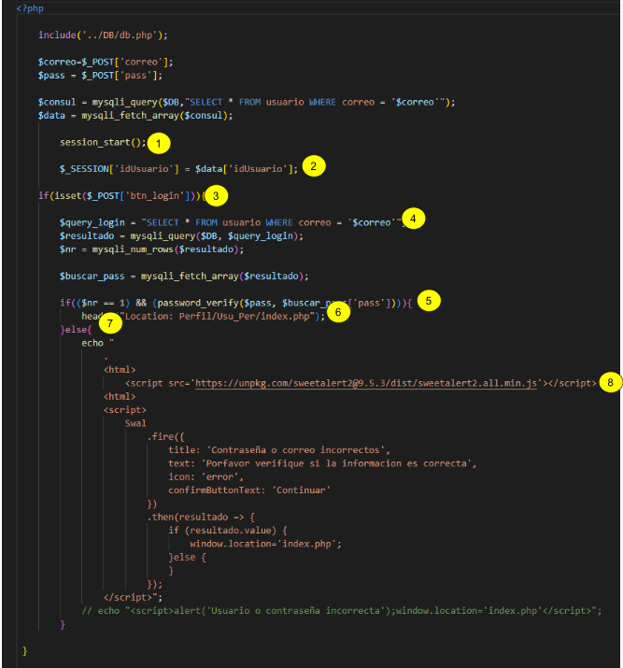

## Grafos (Gráfico)

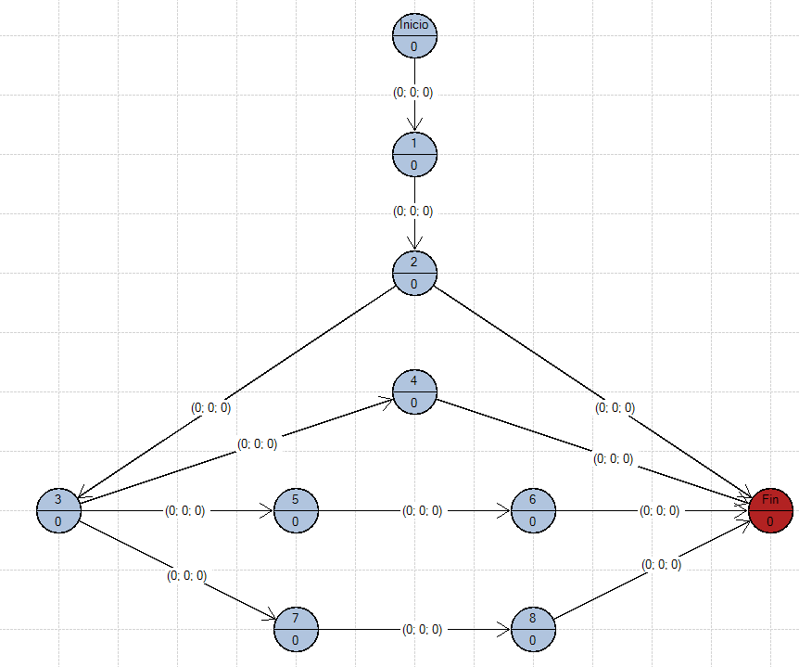

**V(G)= #ARISTA - #NODOS + 2 => V(G)= 10 - 8 + 2 = 4**

## Grafos Caminos

**Camino 1: 1-2-3-fin**

**Camino 2: 1-2-4-5-6-fin**

**Camino 3: 1-2-4-7-8-9-fin**

**Camino 4: 1-2-4-10-11-12-fin**

## 

## Grafos tabla

|  | **Aristas** | | | | | | | | | | | |  |
| --- | --- | --- | --- | --- | --- | --- | --- | --- | --- | --- | --- | --- | --- |
| **Caminos** | **1** | **2** | **3** | **4** | **5** | **6** | **7** | **8** | **9** | **10** | **11** | **12** | **Casos de prueba** |
| **1-2-3-fin** | **1** | **1** | **1** | **0** | **0** | **0** | **0** | **0** | **0** | **0** | **0** | **0** | **$_session=’idUsuario’, return index.php?idUsuario** |
| **1-2-4-5-6-fin** | **1** | **1** | **0** | **1** | **1** | **1** | **0** | **0** | **0** | **0** | **0** | **0** | **$btn_login=true, return $query_login** |
| **1-2-4-7-8-9-fin** | **1** | **1** | **0** | **0** | **0** | **0** | **1** | **1** | **1** | **0** | **0** | **0** | **$nr == 1 && password_verify($pass, $buscar_pass[‘pass’]) = true, return Location: Perfil/index.php** |
| **1-2-4-10-11-12-fin** | **1** | **1** | **0** | **1** | **0** | **0** | **0** | **0** | **0** | **1** | **1** | **1** | **$nr == 0 && password_verify($pass, $buscar_pass[‘pass’]) = false, return echo “<script> alert(‘usuario o contraseña incorrecto’)”** |

**Carrito de compras**

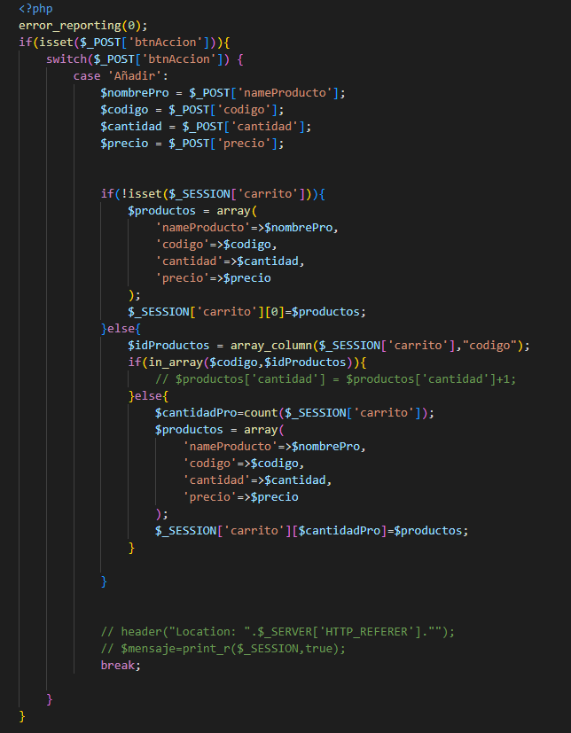

**Grafos(gráficos)**

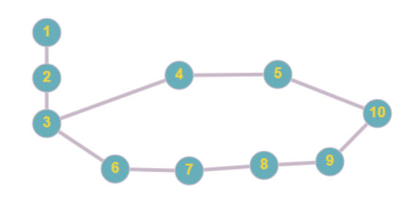

**V(G) = #ARISTAS - #NODOS + 2 => V(G) = 10 - 10 + 2 = 2**

**Grafos caminos**

**Caminos 1: 1-2-3-4-5-10.**

**Caminos 2: 1-2-3-6-7-8-9-10.**

**Grafos tablas**

|  | **Aristas** | | | | | | | | | |  |
| --- | --- | --- | --- | --- | --- | --- | --- | --- | --- | --- | --- |
| **Caminos** | **1** | **2** | **3** | **4** | **5** | **6** | **7** | **8** | **9** | **10** | **Casos de prueba** |
| **1-2-3-4-5-10-fin** | **1** | **1** | **1** | **1** | **1** | **0** | **0** | **0** | **0** | **1** | **Se añade el primer producto que no se visualiza en el carrito.** |
| **1-2-3-6-7-8-9-10-fin** | **1** | **1** | **1** | **0** | **0** | **1** | **1** | **1** | **1** | **1** | **Se añade de manera automática al carrito la prenda seleccionada.** |

# Redireccionamiento

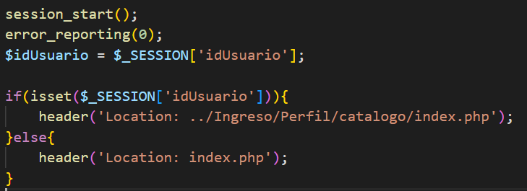

**Grafos (Gráficos)**

**V(G) = #ARISTAS - #NODOS + 2 => V(G) = ? - 7 + 2 =**

**Grafos caminos**

**Camino 1:** 1-2-3-4-Fin

**Camino 2:** 1-2-5-6-Fin

|  | Aristas | | | | | | |  |
| --- | --- | --- | --- | --- | --- | --- | --- | --- |
| Caminos | 1 | 2 | 3 | 4 | 5 | 6 | 7 | Casos de prueba |
| 1-2-3-4-Fin | 1 | 1 | 1 | 1 | 0 | 0 | 1 | $idUsuario = defined; return header(“Location: ../Ingreso/Perfil/catalogo/index.php”); |
| 1-2-5-6-Fin | 1 | 1 | 0 | 0 | 1 | 1 | 1 | $idUsuario = undefined; return header(“Location: index.php”); |

Productos

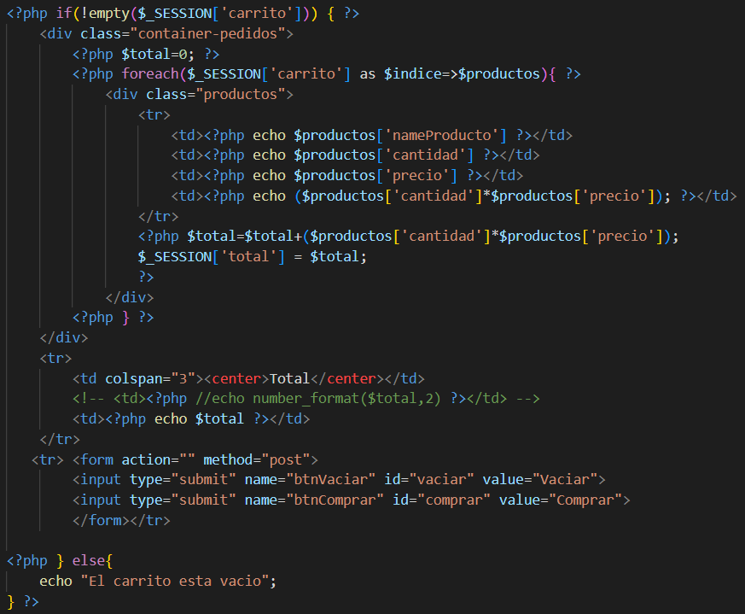

**Grafos(Gráfico)**

**V(G) = #ARISTAS - #NODOS + 2 => V(G) = ? - 8 + 2 =**

**Caminos**

**Camino 1:** 1-2-3-4-5-Fin

**Camino 2:** 1-2-3-Fin

**Camino 3:** 1-6-7-Fin

|  | Aristas | | | | | | | |  |
| --- | --- | --- | --- | --- | --- | --- | --- | --- | --- |
| Caminos | 1 | 2 | 3 | 4 | 5 | 6 | 7 | 8 | Casos de prueba |
| 1-2-3-4-5-Fin | 1 | 1 | 1 | 1 | 1 | 0 | 0 | 1 | $_SESSION[‘carrito’]=defined; return $total = 0;$productos AS $indice; |
| 1-2-3-6-7-Fin | 1 | 1 | 1 | 0 | 0 | 0 | 0 | 1 | $_SESSION=defined; return $total = 0 |
| 1-6-7-Fin | 1 | 0 | 0 | 0 | 0 | 1 | 1 | 1 | $_SESSION=undefined; return echo “El carrito está vacio”; |